Transmission Lines
Inductance and capacitance calculations for transmission lines. GMR, GMD, L, and C matrices, effect of ground conductivity. Underground cables.
1. Equivalent Circuit for Transmission Lines (Including Overhead and Underground)
The power system model for transmission lines is developed from the conventional distributed parameter model, shown in Figure 1.
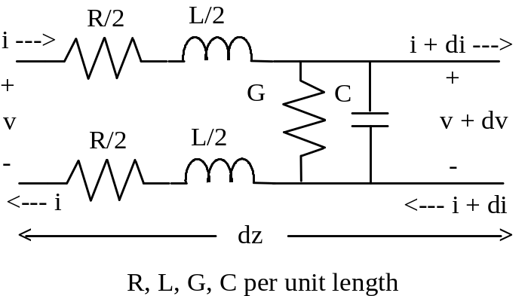
Figure 1. Distributed Parameter Model for Transmission Line
Once the values for distributed parameters resistance R, inductance L, conductance G, and capacitance are known (units given in per unit length), then either "long line" or "short line" models can be used, depending on the electrical length of the line.
Assuming for the moment that R, L, G, and C are known, the relationship between voltage and current on the line may be determined by writing Kirchhoff's voltage law (KVL) around the outer loop in Figure 1, and by writing Kirchhoff's current law (KCL) at the right-hand node.
KVL yields
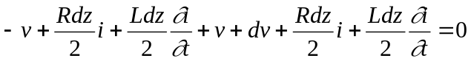.
This yields the change in voltage per unit length, or
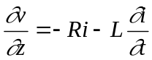 ,
which in phasor form is
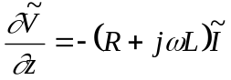 .
KCL at the right-hand node yields
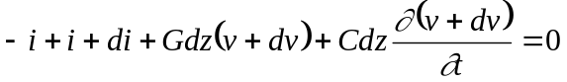 .
If dv is small, then the above formula can be approximated as
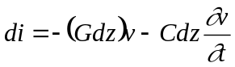 , or 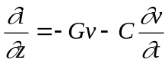 , which in phasor form is
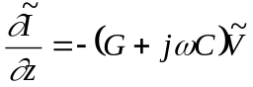 .
Taking the partial derivative of the voltage phasor equation with respect to z yields
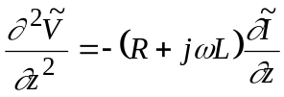 .
Combining the two above equations yields
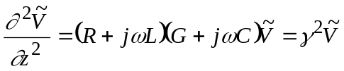 , where 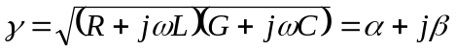 , and where , , and  are the propagation, attenuation, and phase constants, respectively.
The solution for 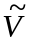 is
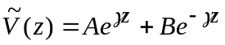 .
A similar procedure for solving yields
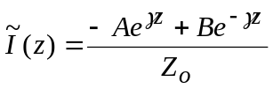 ,
where the characteristic or "surge" impedance 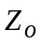 is defined as
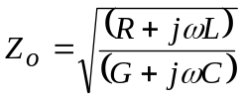 .
Constants A and B must be found from the boundary conditions of the problem. This is usually accomplished by considering the terminal conditions of a transmission line segment that is d meters long, as shown in Figure 2.
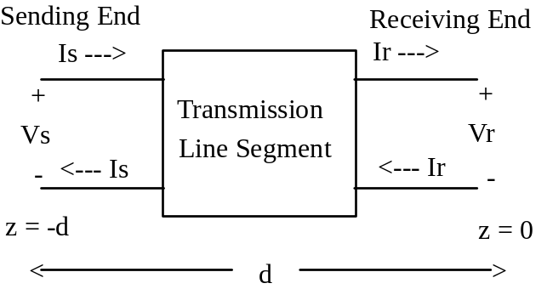
Figure 2. Transmission Line Segment
In order to solve for constants A and B, the voltage and current on the receiving end is assumed to be known so that a relation between the voltages and currents on both sending and receiving ends may be developed.
Substituting z = 0 into the equations for the voltage and current (at the receiving end) yields
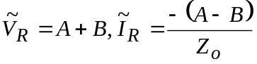 .
Solving for A and B yields
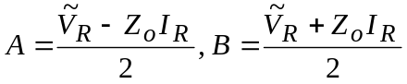.
Substituting into the 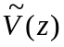 and 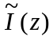 equations yields
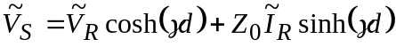 ,
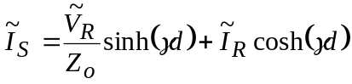 .
A pi equivalent model for the transmission line segment can now be found, in a similar manner as it was for the off-nominal transformer. The results are given in Figure 3.
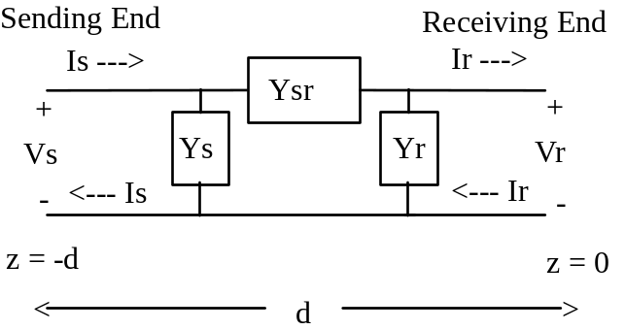
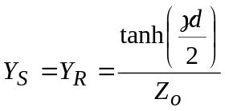 , 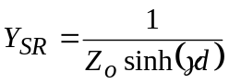 , , 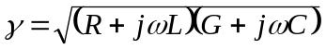
R, L, G, C per unit length
Figure 3. Pi Equivalent Circuit Model for Distributed Parameter Transmission Line
Shunt conductance G is usually neglected in overhead lines, but it is not negligible in underground cables.
For electrically "short" overhead transmission lines, the hyperbolic pi equivalent model simplifies to a familiar form. Electrically short implies that d < 0.05, where wavelength 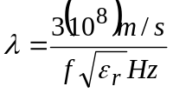 = 5000 km @ 60 Hz, or 6000 km @ 50 Hz. Therefore, electrically short overhead lines have d < 250 km @ 60 Hz, and d < 300 km @ 50 Hz. For underground cables, the corresponding distances are less since cables have somewhat higher relative permittivities (i.e. 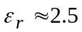 ).
Substituting small values of γd into the hyperbolic equations, and assuming that the line losses are negligible so that G = R = 0, yields
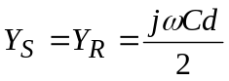 , and 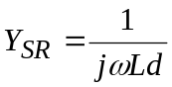 .
Then, including the series resistance yields the conventional "short" line model shown in Figure 4, where half of the capacitance of the line is lumped on each end.
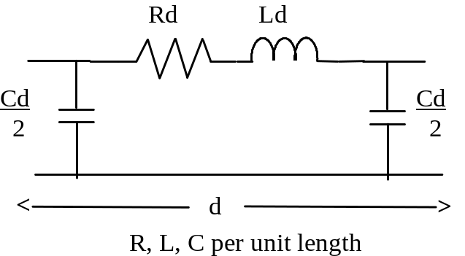
Figure 4. Standard Short Line Pi Equivalent Model for a Transmission Line
2. Capacitance of Overhead Transmission Lines
Overhead transmission lines consist of wires that are parallel to the surface of the Earth. To determine the capacitance of a transmission line, first consider the capacitance of a single wire over the Earth. Wires over the Earth are typically modeled as line charges 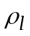 Coulombs per meter of length, and the relationship between the applied voltage and the line charge is the capacitance.
A line charge in space has a radially outward electric field described as
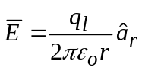 Volts per meter .
This electric field causes a voltage drop between two points at distances r = a and r = b away from the line charge. The voltage is found by integrating electric field, or
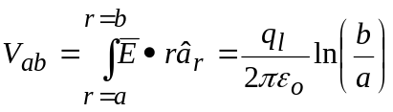 V.
If the wire is above the Earth, it is customary to treat the Earth's surface as a perfect conducting plane, which can be modeled as an equivalent image line charge 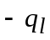 lying at an equal distance below the surface, as shown in Figure 5.
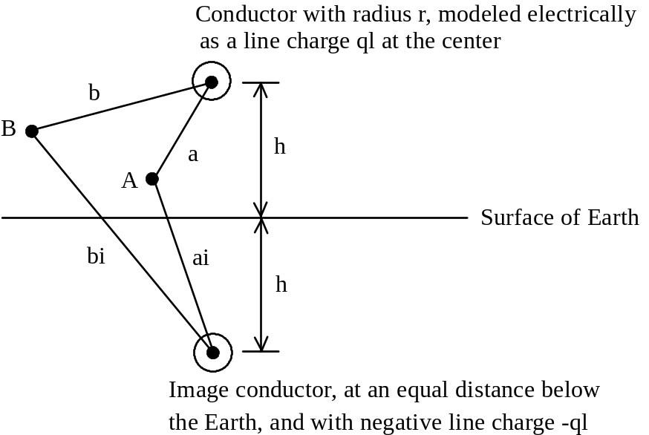
Figure 5. Line Charge 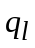 at Center of Conductor Located h Meters Above the Earth
From superposition, the voltage difference between points A and B is
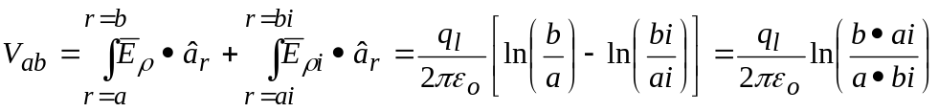 .
If point B lies on the Earth's surface, then from symmetry, b = bi, and the voltage of point A with respect to ground becomes
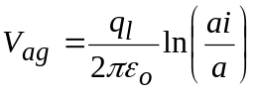 .
The voltage at the surface of the wire determines the wire's capacitance. This voltage is found by moving point A to the wire's surface, corresponding to setting a = r, so that
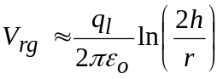 for h >> r.
The exact expression, which accounts for the fact that the equivalent line charge drops slightly below the center of the wire, but still remains within the wire, is
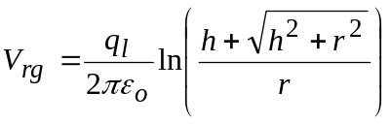 .
The capacitance of the wire is defined as 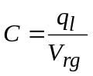 which, using the approximate voltage formula above, becomes
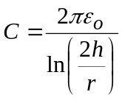 Farads per meter of length.
When several conductors are present, then the capacitance of the configuration is given in matrix form. Consider phase a-b-c wires above the Earth, as shown in Figure 6.
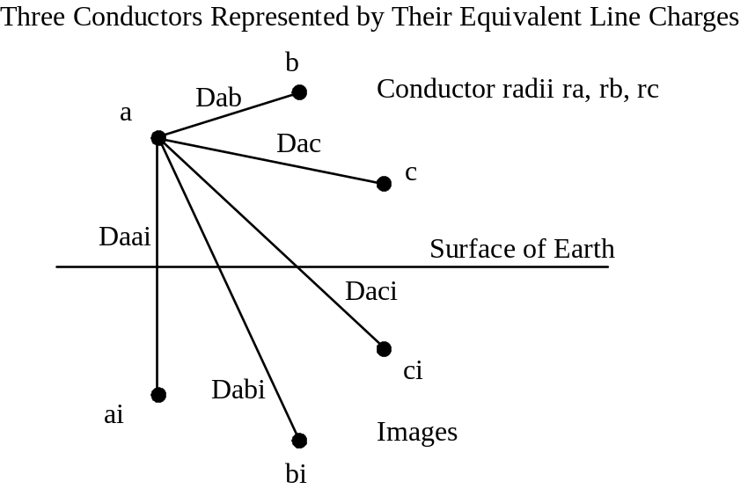
Figure 6. Three Conductors Above the Earth
Superposing the contributions from all three line charges and their images, the voltage at the surface of conductor a is given by
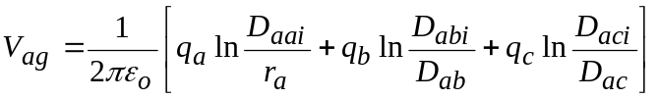 .
The voltages for all three conductors can be written in generalized matrix form as
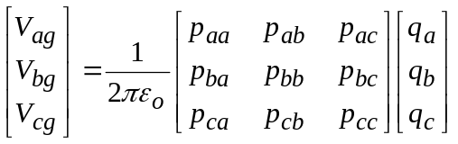 , or 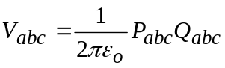 ,
where
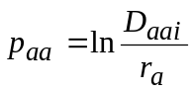 , 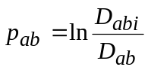 , etc., and
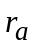 is the radius of conductor a, etc.,
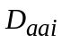 is the distance from conductor a to its own image (i.e. twice the height of conductor a above ground),
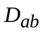 is the distance from conductor a to conductor b,
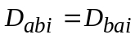 is the distance between conductor a and the image of conductor b (which is the same as the distance between conductor b and the image of conductor a), etc. Therefore, P is a symmetric matrix.
A Matrix Approach for Finding C
From the definition of capacitance, 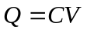, then the capacitance matrix can be obtained via inversion, or
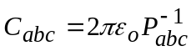 .
If ground wires are present, the dimension of the problem increases by the number of ground wires. For example, in a three-phase system with two ground wires, the dimension of the P matrix is 5 x 5. However, given the fact that the line-to-ground voltage of the ground wires is zero, equivalent 3 x 3 P and C matrices can be found by using matrix partitioning and a process known as Kron reduction. First, write the V = PQ equation as follows:
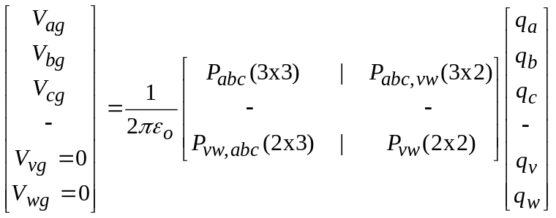 ,
or
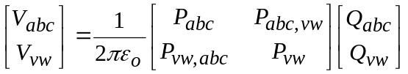 ,
where subscripts v and w refer to ground wires w and v, and where the individual P matrices are formed as before. Since the ground wires have zero potential, then
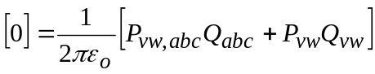,
so that
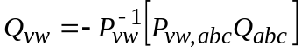 .
Substituting into the 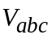 equation above, and combining terms, yields
,
or
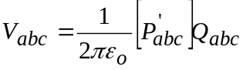 , so that
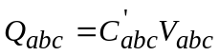 , where 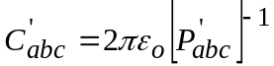 .
Therefore, the effect of the ground wires can be included into a 3 x 3 equivalent capacitance matrix.
An alternative way to find the equivalent 3 x 3 capacitance matrix 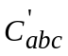 is to
- Gaussian eliminate rows 3,2,1 using row 5 and then row 4. Afterward, rows 3,2,1 will have zeros in columns 4 and 5. 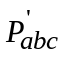 is the top-left 3 x 3 submatrix.
- Invert 3 by 3 to obtain .
Computing 012 Capacitances from Matrices
Once the 3 x 3 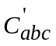 matrix is found by either of the above two methods, 012 capacitances are determined by averaging the diagonal terms, and averaging the off-diagonal terms of, to produce
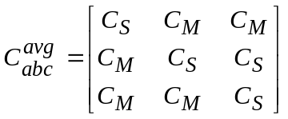 .
The diagonal terms of C are positive, and the off-diagonal terms are negative. 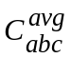 has the special symmetric form for diagonalization into 012 components, which yields
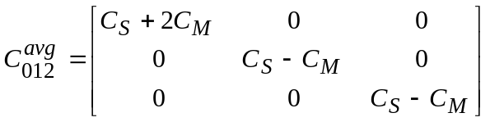 .
The Approximate Formulas for 012 Capacitances
Asymmetries in transmission lines prevent the P and C matrices from having the special form that perfect diagonalization into decoupled positive, negative, and zero sequence impedances. Transposition of conductors can be used to nearly achieve the special symmetric form and, hence, improve the level of decoupling. Conductors are transposed so that each one occupies each phase position for one-third of the lines total distance. An example is given below in Figure 7, where the radii of all three phases are assumed to be identical.
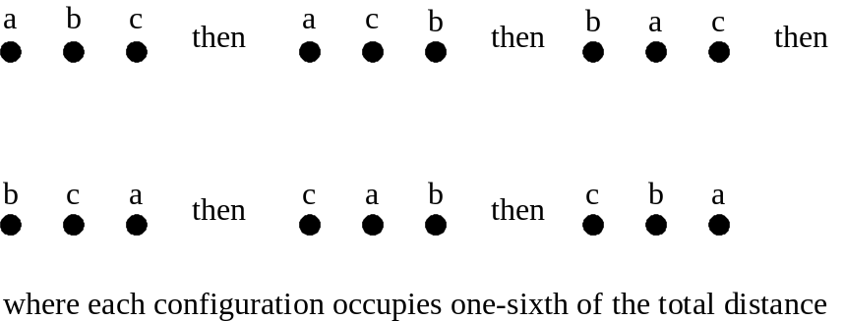
Figure 7. Transposition of A-B-C Phase Conductors
For this mode of construction, the average P matrix (or Kron reduced P matrix if ground wires are present) has the following form:
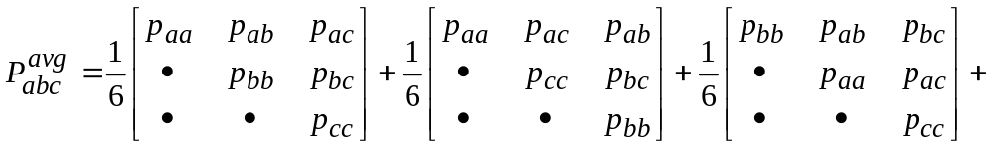
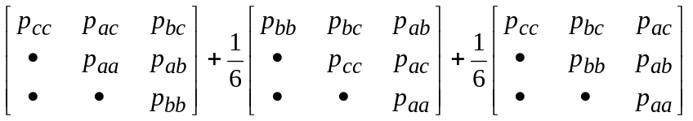 ,
where the individual p terms are described previously. Note that these individual P matrices are symmetric, since 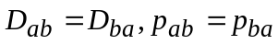 , etc. Since the sum of natural logarithms is the same as the logarithm of the product, P becomes
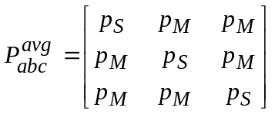 ,
where
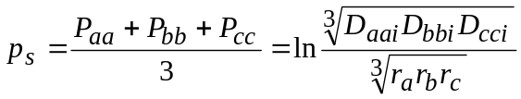 ,
and
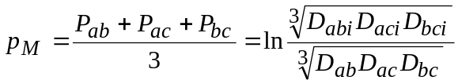 .
Since 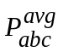 has the special property for diagonalization in symmetrical components, then transforming it yields
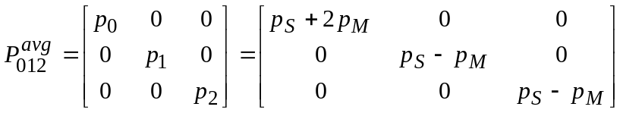 .
The pos/neg sequence values are
.
When the a-b-c conductors are closer to each other than they are to the ground, then
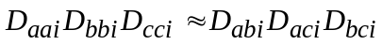 ,
yielding the conventional approximation
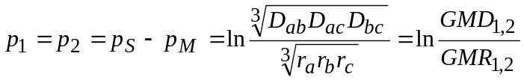 ,
where 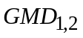 and 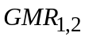 are the geometric mean distance (between conductors) and geometric mean radius, respectively, for both positive and negative sequences.
The zero sequence value is
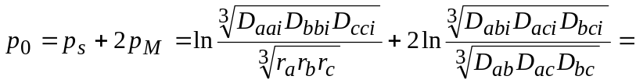
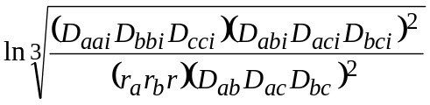 .
Expanding yields
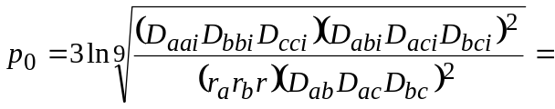
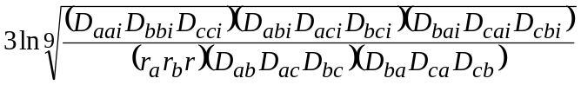 ,
or
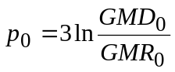 ,
where
,
.
Inverting 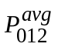 and multiplying by 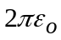 yields the corresponding 012 capacitance matrix
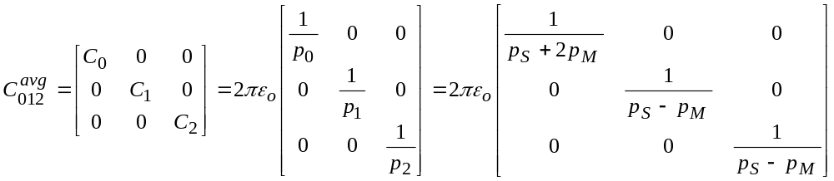
Thus, the pos/neg sequence capacitance is
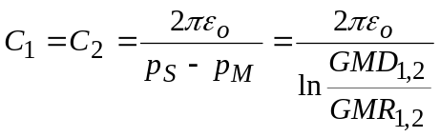 Farads per meter,
and the zero sequence capacitance is
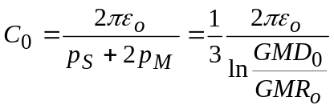 Farads per meter,
which is one-third that of the entire a-b-c bundle by because it represents the charge due to only one phase of the abc bundle.
Bundled Phase Conductors
If each phase consists of a symmetric bundle of N identical individual conductors, an equivalent radius can be computed by assuming that the total line charge on the phase divides equally among the N individual conductors. The equivalent radius is
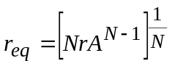 ,
where r is the radius of the individual conductors, and A is the bundle radius of the symmetric set of conductors. Three common examples are shown below in Figure 8.
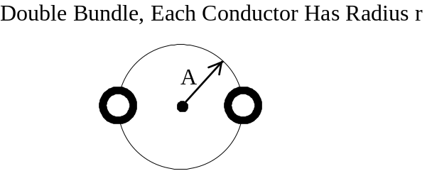
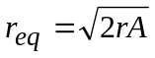
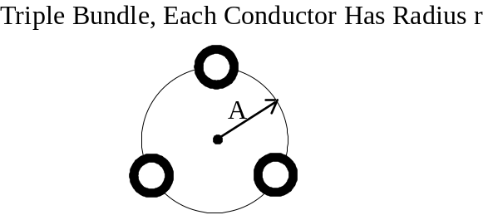
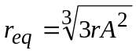
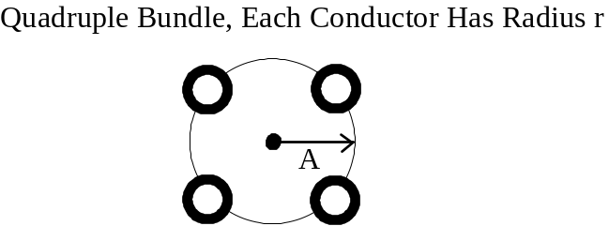
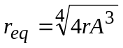
Figure 8. Equivalent Radius for Three Common Types of Bundled Phase Conductors
3. Inductance
The magnetic field intensity produced by a long, straight current carrying conductor is given by Ampere's Circuital Law to be
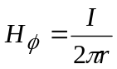 Amperes per meter,
where the direction of 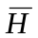 is given by the right-hand rule.
Magnetic flux density is related to magnetic field intensity by permeability  as follows:
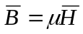 Webers per square meter,
and the amount of magnetic flux passing through a surface is
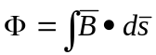 Webers,
where the permeability of free space is 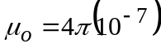.
Two Parallel Wires in Space
Now, consider a two-wire circuit that carries current I, as shown in Figure 9.
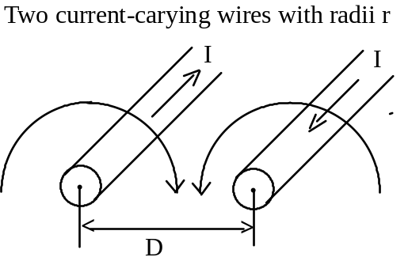
Figure 9. A Circuit Formed by Two Long Parallel Conductors
The amount of flux linking the circuit (i.e. passes between the two wires) is found to be
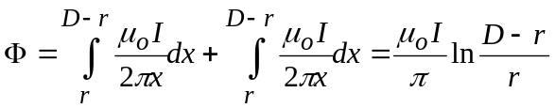 Henrys per meter length.
From the definition of inductance,
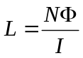 ,
where in this case N = 1, and where N >> r, the inductance of the two-wire pair becomes
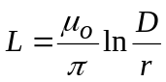 Henrys per meter length.
A round wire also has an internal inductance, which is separate from the external inductance shown above. The internal inductance is shown in electromagnetics texts to be
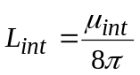 Henrys per meter length.
For most current-carrying conductors, 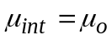 so that 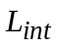 = 0.05µH/m. Therefore, the total inductance of the two-wire circuit is the external inductance plus twice the internal inductance of each wire (i.e. current travels down and back), so that
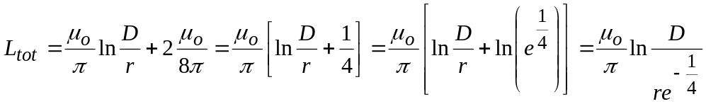 .
It is customary to define an effective radius
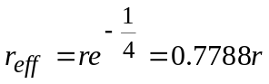 ,
and to write the total inductance in terms of it as
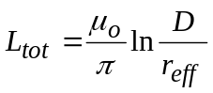 Henrys per meter length.
Wire Parallel to Earth’s Surface
For a single wire of radius r, located at height h above the Earth, the effect of the Earth can be described by an image conductor, as it was for capacitance calculations. For perfectly conducting earth, the image conductor is located h meters below the surface, as shown in Figure 10.
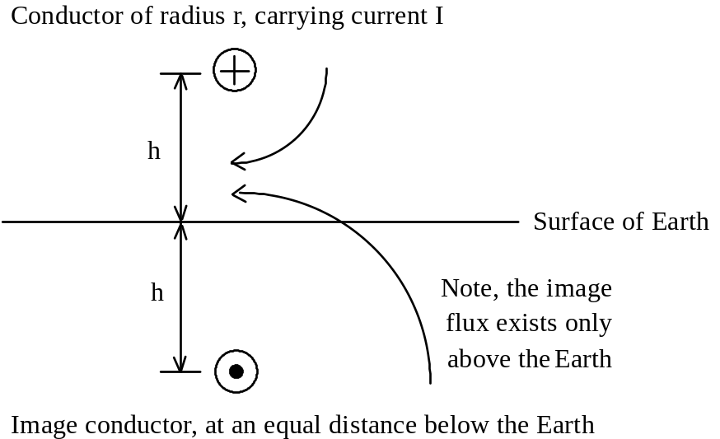
Figure 10. Current-Carrying Conductor Above the Earth
The total flux linking the circuit is that which passes between the conductor and the surface of the Earth. Summing the contribution of the conductor and its image yields
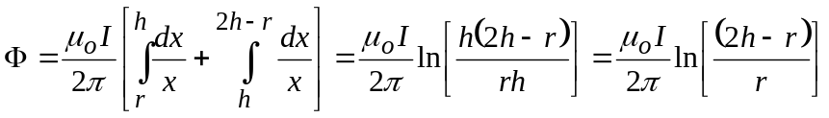 .
For 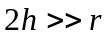, a good approximation is
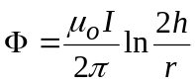 Webers per meter length,
so that the external inductance per meter length of the circuit becomes
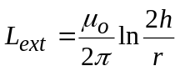 Henrys per meter length.
The total inductance is then the external inductance plus the internal inductance of one wire, or
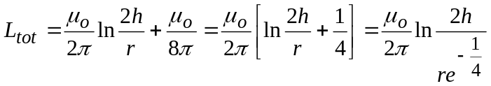 ,
or, using the effective radius definition from before,
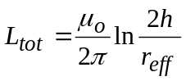 Henrys per meter length.
Bundled Conductors
The bundled conductor equivalent radii presented earlier apply for inductance as well as for capacitance. The question now is “what is the internal inductance of a bundle?” For N bundled conductors, the net internal inductance of a phase per meter must decrease as 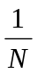 because the internal inductances are in parallel. Considering a bundle over the Earth, then
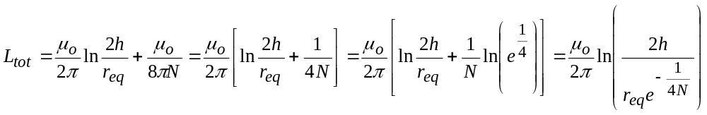 .
Factoring in the expression for the equivalent bundle radius 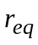 yields
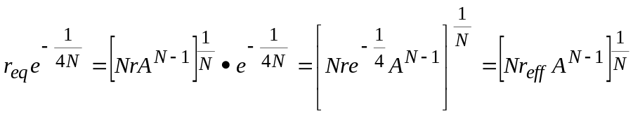
Thus, 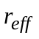 remains 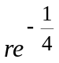, no matter how many conductors are in the bundle.
The Three-Phase Case
For situations with multiples wires above the Earth, a matrix approach is needed. Consider the capacitance example given in Figure 6, except this time compute the external inductances, rather than capacitances. As far as the voltage (with respect to ground) of one of the a-b-c phases is concerned, the important flux is that which passes between the conductor and the Earth's surface. For example, the flux "linking" phase a will be produced by six currents: phase a current and its image, phase b current and its image, and phase c current and its image, and so on. Figure 11 is useful in visualizing the contribution of flux “linking” phase a that is caused by the current in phase b (and its image).

a
ai
b
bi
Dab
Dbg
Dbg
Dabi
g
Figure 11. Flux Linking Phase a Due to Current in Phase b and Phase b Image

The linkage flux is
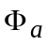(due to 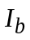 and image) = 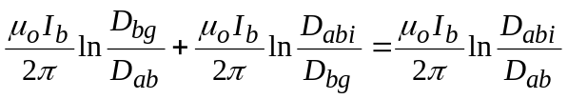 .
Considering all phases, and applying superposition, yields the total flux
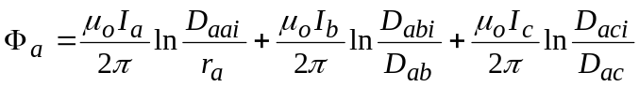 .
Note that corresponds to 2h in Figure 10. Performing the same analysis for all three phases, and recognizing that 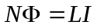 , where N = 1 in this problem, then the inductance matrix is developed using
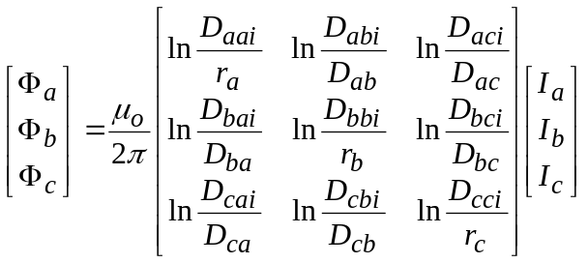 , or 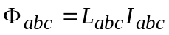 .
A comparison to the capacitance matrix derivation shows that the same matrix of natural logarithms is used in both cases, and that
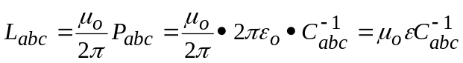 .
This implies that the product of the L and C matrices is a diagonal matrix with 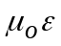 on the diagonal, providing that the Earth is assumed to be a perfect conductor and that the internal inductances of the wires are ignored.
If the circuit has ground wires, then the dimension of L increases accordingly. Recognizing that the flux linking the ground wires is zero (because their voltages are zero), then L can be Kron reduced to yield an equivalent 3 x 3 matrix 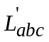.
To include the internal inductance of the wires, replace actual conductor radius r with .
Computing 012 Inductances from Matrices
Once the 3 x 3 matrix is found, 012 inductances can be determined by averaging the diagonal terms, and averaging the off-diagonal terms, of to produce
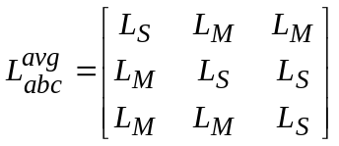 ,
so that
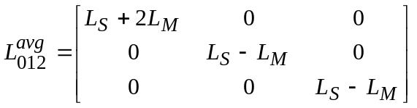 .
The Approximate Formulas for 012 Inductancess
Because of the similarity to the capacitance problem, the same rules for eliminating ground wires, for transposition, and for bundling conductors apply. Likewise, approximate formulas for the positive, negative, and zero sequence inductances can be developed, and these formulas are
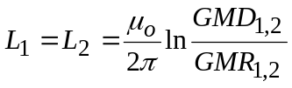 ,
and
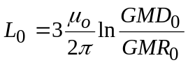 .
It is important to note that the GMD and GMR terms for inductance differ from those of capacitance in two ways:
1. GMR calculations for inductance calculations should be made with 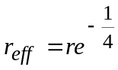.
2. GMD distances for inductance calculations should include the equivalent complex depth for modeling finite conductivity earth (explained in the next section). This effect is ignored in capacitance calculations because the surface of the Earth is nominally at zero potential.
Modeling Imperfect Earth
The effect of the Earth's non-infinite conductivity should be included when computing inductances, especially zero sequence inductances. (Note - positive and negative sequences are relatively immune to Earth conductivity.) Because the Earth is not a perfect conductor, the image current does not actually flow on the surface of the Earth, but rather through a cross-section. The higher the conductivity, the narrower the cross-section.
It is reasonable to assume that the return current is one skin depth δ below the surface of the Earth, where 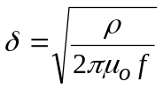 meters. Typically, resistivity  is assumed to be 100Ω-m. For 100Ω-m and 60Hz, δ = 459m. Usually δ is so large that the actual height of the conductors makes no difference in the calculations, so that the distances from conductors to the images is assumed to be δ. However, for cases with low resistivity or high frequency, one should limit delta to not be less than GMD computed with perfect Earth images.

#1
#2
#3
#1’
#2’
#3’
Images
Practice Area

4. Electric Field at Surface of Overhead Conductors
Ignoring all other charges, the electric field at a conductor’s surface can be approximated by
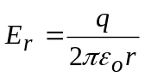 ,
where r is the radius. For overhead conductors, this is a reasonable approximation because the neighboring line charges are relatively far away. It is always important to keep the peak electric field at a conductor’s surface below 30kV/cm to avoid excessive corono losses.
Going beyond the above approximation, the Markt-Mengele method provides a detailed procedure for calculating the maximum peak subconductor surface electric field intensity for three-phase lines with identical phase bundles. Each bundle has N symmetric subconductors of radius r. The bundle radius is A. The procedure is
- Treat each phase bundle as a single conductor with equivalent radius
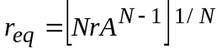 .
- Find the C(N x N) matrix, including ground wires, using average conductor heights above ground. Kron reduce C(N x N) to C(3 x 3). Select the phase bundle that will have the greatest peak line charge value (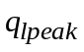) during a 60Hz cycle by successively placing maximum line-to-ground voltage Vmax on one phase, and – Vmax/2 on each of the other two phases. Usually, the phase with the largest diagonal term in C(3 by 3) will have the greatest 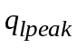.
- Assuming equal charge division on the phase bundle identified in Step 2, ignore equivalent line charge displacement, and calculate the average peak subconductor surface electric field intensity using
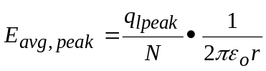
- Take into account equivalent line charge displacement, and calculate the maximum peak subconductor surface electric field intensity using
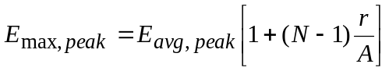 .
5. Resistance and Conductance
The resistance of conductors is frequency dependent because of the resistive skin effect. Usually, however, this phenomenon is small for 50 - 60 Hz. Conductor resistances are readily obtained from tables, in the proper units of ohms per meter length, and these values, added to the equivalent-Earth resistances from the previous section, to yield the R used in the transmission line model.
Conductance G is very small for overhead transmission lines and can be ignored.
6. Underground Cables
Underground cables are transmission lines, and the model previously presented applies. Capacitance C tends to be much larger than for overhead lines, and conductance G should not be ignored.
For single-phase and three-phase cables, the capacitances and inductances per phase per meter length are
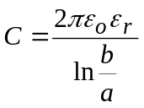 Farads per meter length,
and
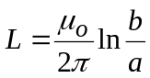 Henrys per meter length,
where b and a are the outer and inner radii of the coaxial cylinders. In power cables, 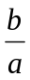 is typically e (i.e., 2.7183) so that the voltage rating is maximized for a given diameter.
For most dielectrics, relative permittivity 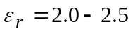. For three-phase situations, it is common to assume that the positive, negative, and zero sequence inductances and capacitances equal the above expressions. If the conductivity of the dielectric is known, conductance G can be calculated using
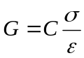 Mhos per meter length.

SUMMARY OF Positive/Negative Sequence HAND Calculations

Assumptions

Balanced, far from ground, ground wires ignored. Valid for identical single conductors per phase, or for identical symmetric phase bundles with N conductors per phase and bundle radius A.

Computation of positive/negative sequence capacitance

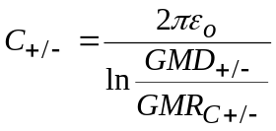 farads per meter,

where

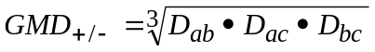 meters,

where 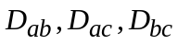 are

- distances between phase conductors if the line has one conductor per phase, or
- distances between phase bundle centers if the line has symmetric phase bundles,

and where

- 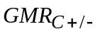 is the actual conductor radius r (in meters) if the line has one conductor per phase, or
- 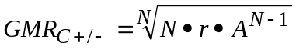if the line has symmetric phase bundles.

Computation of positive/negative sequence inductance

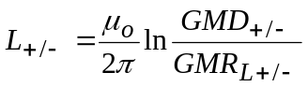 henrys per meter,

where 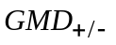 is the same as for capacitance, and

- for the single conductor case, 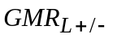 is the conductor 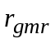 (in meters), which takes into account both stranding and the 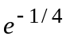 adjustment for internal inductance. If is not given, then assume 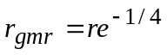, and
- for bundled conductors, 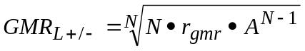if the line has symmetric phase bundles.

Computation of positive/negative sequence resistance

R is the 60Hz resistance of one conductor if the line has one conductor per phase. If the line has symmetric phase bundles, then divide the one-conductor resistance by N.

Some commonly-used symmetric phase bundle configurations
A
A
A
N = 2
N = 3
N = 4

SUMMARY OF ZERO SEQUENCE HAND CALCULATIONS

Assumptions

Ground wires are ignored. The a-b-c phases are treated as one bundle. If individual phase conductors are bundled, they are treated as single conductors using the bundle radius method. For capacitance, the Earth is treated as a perfect conductor. For inductance and resistance, the Earth is assumed to have uniform resistivity . Conductor sag is taken into consideration, and a good assumption for doing this is to use an average conductor height equal to (1/3 the conductor height above ground at the tower, plus 2/3 the conductor height above ground at the maximum sag point).

The zero sequence excitation mode is shown below, along with an illustration of the relationship between bundle C and L and zero sequence C and L. Since the bundle current is actually 3Io, the zero sequence resistance and inductance are three times that of the bundle, and the zero sequence capacitance is one-third that of the bundle.
+
Vo
–
Io →
Io →
Io →
3Io →
Cbundle
+
Vo
–
Io →
Io →
Io →
3Io →
3Io ↓
Lbundle
+
Vo
–
Io →
Io →
Io →
3Io →
Co
Co
Co
Io →
+
Vo
–
Io →
Io →
3Io →
3Io ↓
Lo
Lo
Lo

Computation of zero sequence capacitance

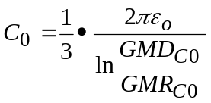 farads per meter,

where 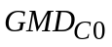 is the average height (with sag factored in) of the a-b-c bundle above perfect Earth. is computed using

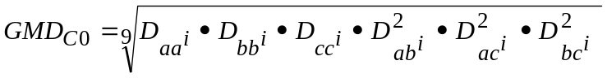 meters,

where 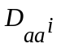 is the distance from a to a-image, 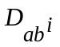 is the distance from a to b-image, and so forth. The Earth is assumed to be a perfect conductor, so that the images are the same distance below the Earth as are the conductors above the Earth. Also,

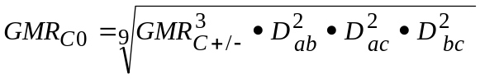 meters,

where , 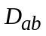, 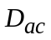, and 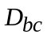 were described previously.

Computation of zero sequence inductance

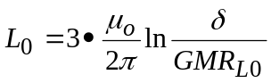 Henrys per meter, 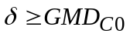

where skin depth meters. Resistivity ρ = 100 ohm-meter is commonly used. For poor soils, ρ = 1000 ohm-meter is commonly used. For 60 Hz, and ρ = 100 ohm-meter, skin depth δ is 459 meters. To cover situations with low resistivity, use (from the previous page) as a lower limit for δ

The geometric mean bundle radius is computed using

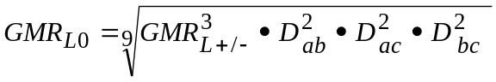 meters,

where 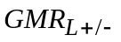, , , and were shown previously.

Computation of zero sequence resistance

There are two components of zero sequence line resistance. First, the equivalent conductor resistance is the 60Hz resistance of one conductor if the line has one conductor per phase. If the line has symmetric phase bundles with N conductors per bundle, then divide the one-conductor resistance by N.

Second, the effect of resistive earth is included by adding the following term to the conductor resistance:

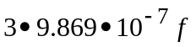 ohms per meter (see Bergen),

where the multiplier of three is needed to take into account the fact that all three zero sequence currents flow through the Earth.

As a general rule,

- 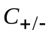 usually works out to be about 12 picoF per meter,
- 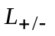 works out to be about 1 microH per meter (including internal inductance).
- 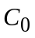 is usually about 6 picoF per meter.
- 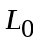 is usually about 2 microH per meter if the line has ground wires and typical Earth resistivity, or about 3 microH per meter for lines without ground wires or poor earth resistivity.
The velocity of propagation, 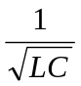, is approximately the speed of light (3 x 10⁸ m/s) for positive and negative sequences, and about 0.8 times that for zero sequence.

5.7 m
4.4 m
7.6 m
8.5 m
22.9 m at tower, and sags down 10 m at mid-span to 12.9 m.
7.6 m
7.8 m
Tower Base
345kV Double-Circuit Transmission Line
Scale: 1 cm = 2 m
Double conductor phase bundles, bundle radius = 22.9 cm, conductor radius = 1.41 cm, conductor resistance = 0.0728 Ω/km

Single-conductor ground wires, conductor radius = 0.56 cm, conductor resistance = 2.87 Ω/km

5 m
10 m
33 m
Tower Base
500kV Single-Circuit Transmission Line
Scale: 1 cm = 2 m
Triple conductor phase bundles, bundle radius = 20 cm, conductor radius = 1.5 cm, conductor resistance = 0.05 Ω/km

Single-conductor ground wires, conductor radius = 0.6 cm, conductor resistance = 3.0 Ω/km

10 m
5 m
39 m
Conductors sag down 10 m at mid-span
30 m
Earth resistivity ρ = 100 Ω-m

Practice Problem.

Use the left-hand circuit of the 345kV line geometry given two pages back. Determine the L, C, R line parameters, per unit length, for positive/negative and zero sequence.

Now, focus on a balanced three-phase case, where only positive sequence is important, and work the following problem using your L, C, R positive sequence line parameters:

For a 200km long segment, determine the P’s, Q’s, I’s, VR, and δR for switch open and switch closed cases. The generator voltage phase angle is zero.



