[](http://www.ecs.baylor.edu/engineering/bears/)

Thursday, March 6, 2014, 3:30 PM, 312 Rogers Bldg

Cognitive Networking and Sensing: A Big Data Way

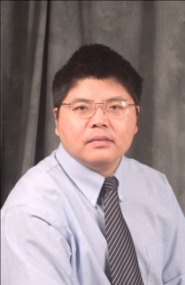

Robert C. Qiu

Department of Electrical and Computer Engineering

Tennessee Technological University

ABSTRACT---This talk is based on a simple observation that datasets can be naturally represented by large random matrices. Although an old subject for more than half a century, large random matrices play a new role, due to the emerging big data. The above simple observation has far-reaching consequences: (1) non-commutative algebra such as free probability theory becomes the natural tool; (2) High-dimensional Riemann geometry is the natural space to study for big data. The above models are validated by experimental data, which are collected using 70-node cognitive radio network testbed and in-house UWB-MIMO radar system.

