Name_____________________________________________ USF ID#_________________________

EEL 3100 – Network Analysis and Design
Fall 2005
Test 3 – December 7, 2005
Closed Book/Closed Notes
1 hour and 15 minutes

1. The exam is closed-book/ closed-notes.

2. A calculator may be used to assist with the test. No laptops or PDAs are allowed. You are not allowed to bring any information into the test stored on your calculator.

3. You must circle or box your answers to get full credit.

4. All work and steps toward a solution must be clearly shown to obtain credit.

5. Partial credit may be given provided that the grader can clearly follow your work to the extent that an understanding of the problem is demonstrated.

6. No collaboration is allowed on this examination. Only Charles Baylis or an APEX proctor may be consulted for clarification.

7. You may attach extra sheets to the exam if necessary. Each page should contain your name, the problem number, and the page number for that problem.

Please sign the statement below. YOU MUST SIGN THE STATEMENT OR YOU WILL GET A ZERO FOR THIS EXAMINATION!!!

I hereby testify that I have neither provided or received information during the test and that this test is the sole product of my effort.

Signed ________________________________________ Date_____________________

PROBLEM 1 (20 points): Consider the following circuit:
.
.
I₁
I₂
I₃
2 H
+

-
Assume sinusoidal excitation given by V_{s} = 4<0˚ V and write three KVL (loop) equations for the following circuit in terms of I₁(jω), I₂(jω), and I₃(jω). Fill in your answer on the form provided at the bottom of the page.

__________________I₁ + ___________________ I₂ + ___________________I₃ = _________________
__________________I₁ + ___________________ I₂ + ___________________I₃ = _________________
__________________I₁ + ___________________ I₂ + ___________________I₃ = _________________
PROBLEM 2 (20 points): Consider the following circuit containing an ideal transformer:
.
.
+
V_{out}
__
+

-

Using your knowledge of the voltage and impedance relationships for an ideal transformer, find V_{out} assuming a sinusoidal steady-state excitation of 10 V rms.

PROBLEM 3 (20 points): Consider the following directed graph:
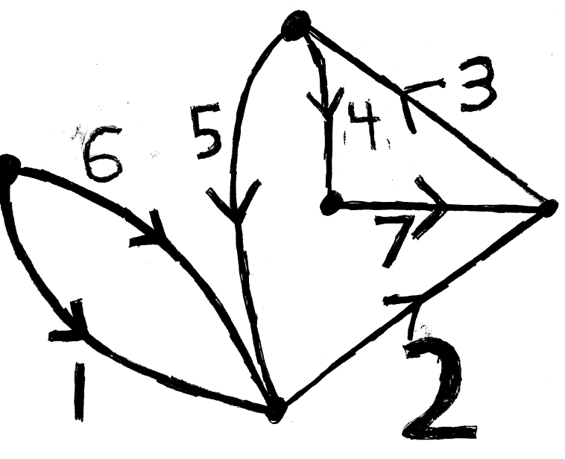
Use the tree {1, 2, 3, 4} for the analysis in this problem.
You may redraw the graph here for convenience with the tree branches as solid lines and the links as dashed lines:

(a) Find the fundamental cut-set matrix [Q] associated with the given tree by writing a set of linearly independent KCL equations (one for each tree branch) (10 points)

(Problem 3 continued on next page)

(b) Find the fundamental loop matrix [B] associated with the given tree by writing a set of linearly independent KVL equations (one for each link) (10 points).

PROBLEM 4 (20 points): Consider the following circuit:

i₆
i₁
i₂
i₃
i₄
i₅
6i₅
Recall that branch equations for the circuit can be written in the form
$$[M][V]+[N][I]=[U]$$
Using the branch numbers and directions as provided by the indicated currents, find [M], [N], and the source vector [U] by writing an equation for each branch in the s-domain. Assume all initial conditions are zero.

PROBLEM 5 (20 points): Consider the following circuit:
i_{L}
5i_{L}

+
v_{C1}
_

+
v_{C2}
_
Using the state variables v_{C1}, v_{C2}, i_{L} (in that order), write the normal-form equations for the circuit above (use f(t) as the voltage source).

